Program 11: Demonstrate create, add, remove union and insertion operations on a tuple.

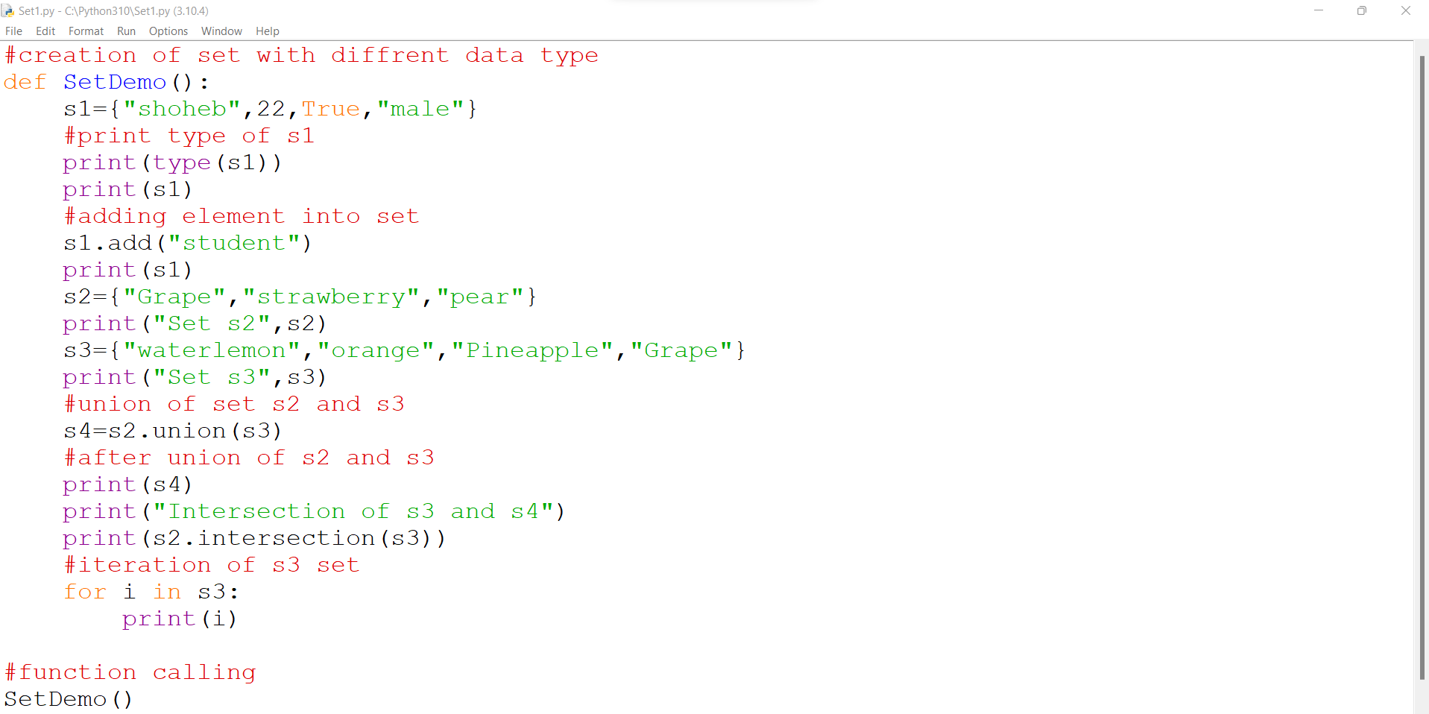

Output:

